Understanding Computer Hardware

12.1 Introduction
Computers begin as a hardware device but can grow to encompass virtual machines that are entirely constructed out of software and appear to all purposes to be a remote machine that users can access via remote protocols and methods.

12.2 Motherboards
The motherboard, or system board, is the main hardware board in the computer through which the central processing unit (CPU), random-access memory (RAM) and other components are all connected. Depending on the computer type (laptop, desktop, server) some devices, such as processors and RAM, are attached directly to the motherboard, while other devices, such as add-on cards, are connected via a bus.

12.3 Processors
A central processing unit (CPU or processor) is one of the most critical hardware components of a computer. The processor is the brain of the computer, where the execution of code takes place and where most calculations are done. It is directly connected (soldered) to the motherboard, as motherboards are typically configured to work with specific types of processors.
To see which family the CPU of the current system belongs to, use the arch command:
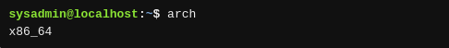

For more information concerning the CPU, use the lscpu command:
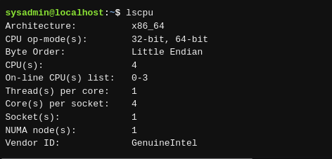

12.4 Random Access Memory
The motherboard typically has slots where random-access memory (RAM) can be connected to the system. The 32-bit architecture systems can use up to 4 gigabytes (GB) of RAM, while 64-bit architectures are capable of addressing and using far more RAM.
To view the amount of RAM in your system, including the swap space, execute the free command. The free command has a -m option to force the output to be rounded to the nearest megabyte (MB) and a -g option to force the output to be rounded to the nearest gigabyte (GB):
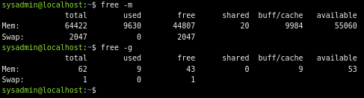

12.5 Buses
A bus is a high-speed connection that allows communication between computers or the components inside a computer. The motherboard has buses that allow for multiple devices to connect to the system, including the Peripheral Component Interconnect (PCI) and Universal Serial Bus (USB). The motherboard also has connectors for monitors, keyboards and mice.

Peripheral Devices
Peripheral devices are components connected to a computer that allow input, output or data storage. Keyboards, mice, monitors, printers and hard disks are all considered peripherals and are accessed by the system in order to perform functions outside of central processing. To view all of the devices connected by the PCI bus, the user can execute the lspci command.
To display the devices connected to the system via USB, execute the lsusb command.

12.6 Hard Drives
Hard drives, also called hard disks, disk devices, or storage devices, may be attached to the system in a number of ways; the controller may be integrated into the motherboard, on a PCI card, or as a USB device. For the purposes of most Linux systems, a hard drive can generally be defined as any electromechanical or electronic storage device that holds data to be accessed by the system.
Some hard drives make use of a partitioning technology called Master Boot Record (MBR) while others make use of a partitioning type called GUID Partitioning Table (GPT). The MBR type of partitioning has been used since the early days of the Personal Computer (PC), and the GPT type has been available since the year 2000.

An old term used to describe an internal hard disk is fixed disk, as the disk is fixed (not removable). This term gave rise to several command names: the fdisk, cfdisk and sfdisk commands, which are tools for working with the MBR partitioned disks.
The GPT disks use a newer type of partitioning, which allows the user to divide the disk into more partitions than what MBR supports. GPT also allows having partitions which can be larger than two terabytes (MBR does not). The tools for managing GPT disks are named similarly to their fdisk counterparts: gdisk, cgdisk, and sgdisk.
There is also a family of tools that attempt to support both MBR and GPT type disks. This set of tools includes the parted command and the graphical gparted tool.
Hard drives are associated with file names (called device files) that are stored in the /dev directory. Each device file name is made up of multiple parts.
- File Type
The file name is prefixed based on the different types of hard drives. IDE (Intelligent Drive Electronics) hard drives begin with hd, while USB, SATA (Serial Advanced Technology Attachment) and SCSI (Small Computer System Interface) hard drives begin with sd.
- Device Order
Each hard drive is then assigned a letter which follows the prefix. For example, the first IDE hard drive would be named /dev/hda and the second would be /dev/hdb, and so on.
- Partition
Finally, each partition on a disk is given a unique numeric indicator. For example, if a USB hard drive has two partitions, they could be associated with the /dev/sda1 and /dev/sda2 device files.
The fdisk command can be used to display further information about the partitions:
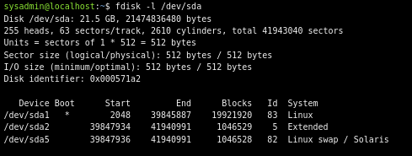

12.7 Solid State Disks
Solid state disks are essentially larger capacity USB thumb drives in construction and function. As there are no moving parts, and no spinning disks, just memory locations to be read by the controller, a solid state disk is measurably and visibly faster in accessing the information stored in its memory chips.
A solid state disk is controlled by an embedded or onboard processor that makes the decisions as to where and how data is written and read back from the memory chips when requested.
Advantages of a solid state disk include lower power usage, time savings in system booting, faster program loads, and less heat and vibration from no moving parts. Disadvantages include higher costs in comparison to spinning hard disks, lower capacity due to the higher cost, and if soldered directly on the motherboard/mainboard, no ability to upgrade by swapping out the drive.

12.8 Optical Drives
Optical drives, often referred to as CD-ROMs, DVDs, or Blu-Ray, are removable storage media. While some devices used with optical disks are read-only, others are capable of burning (writing to) disks, when using a writable type of disk. There are various standards for writable and rewritable disks, such as CD-R, CD+R, DVD+RW, and DVD-RW.

